# **Building CI-CD Pipeline Tool**

**Task 1: Set Up a Simple HTML Project**

1. Create the HTML Project:

Create a new directory for project

“mkdir my_html_project”

“cd my_html_project”

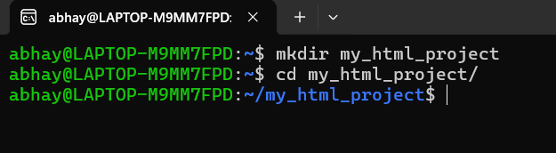

Create a simple index.html file inside this directory:

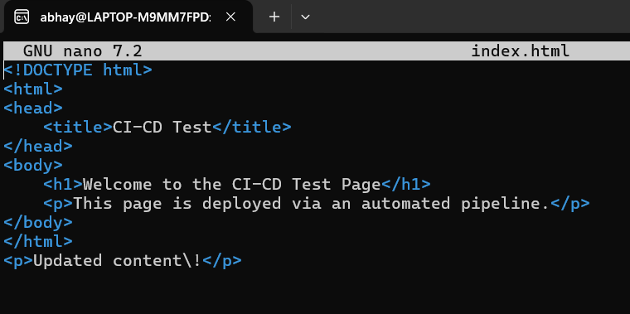

1. Push to GitHub:

“git init”

“git add index.html”

“git commit -m "Initial commit with simple HTML project"

Create a new repository on GitHub.

Add the GitHub repository as a remote:

“git remote add origin <https://github.com/AbhayShukla/my_html_project.git>”

Push the code to GitHub:

“git push -u origin master”

**Task 2: Set Up an AWS EC2/Local Linux Instance with Nginx**

1. Install & start Nginx:

“sudo apt update”

“sudo apt install nginx”

“sudo apt start nginx”

**Task 3: Write a Python Script to Check for New Commits**

1. Create the Python Script:

“nano check_commits.py”

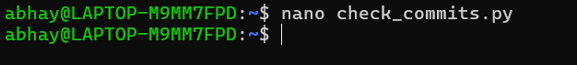

Add the following code to the file:

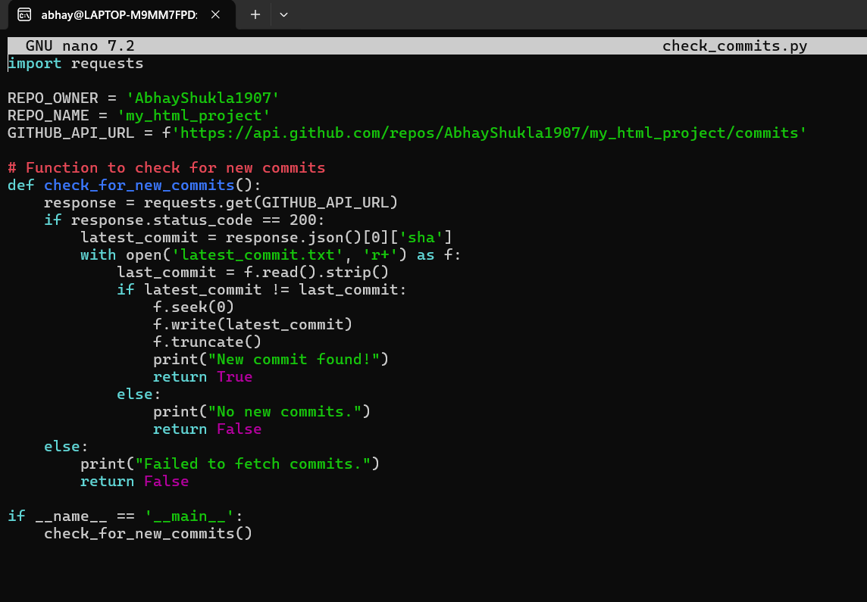

1. Create a File to Store the Latest Commit:

“echo "" > latest_commit.txt”

**Task 4: Write a Bash Script to Deploy the Code**

1. Create the Bash Script:

“nano deploy.sh”

Add the following code to the file:

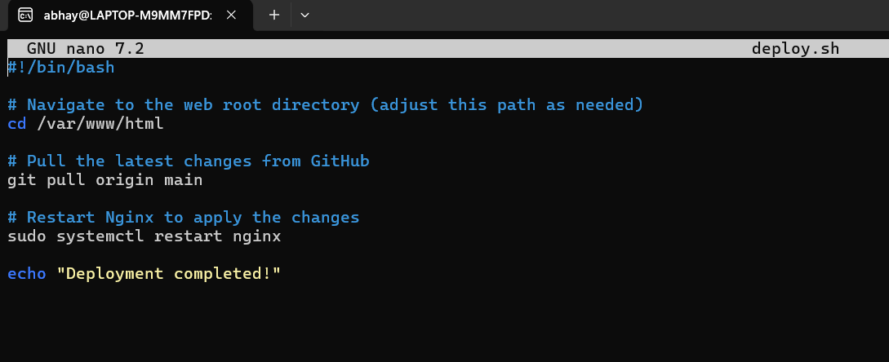

1. Make the Script Executable:

“chmod +x deploy.sh”

**Task 5: Set Up a Cron Job to Run the Python Script**

1. Edit the Crontab:

“crontab -e”

Add the following line to run the Python script every minute:

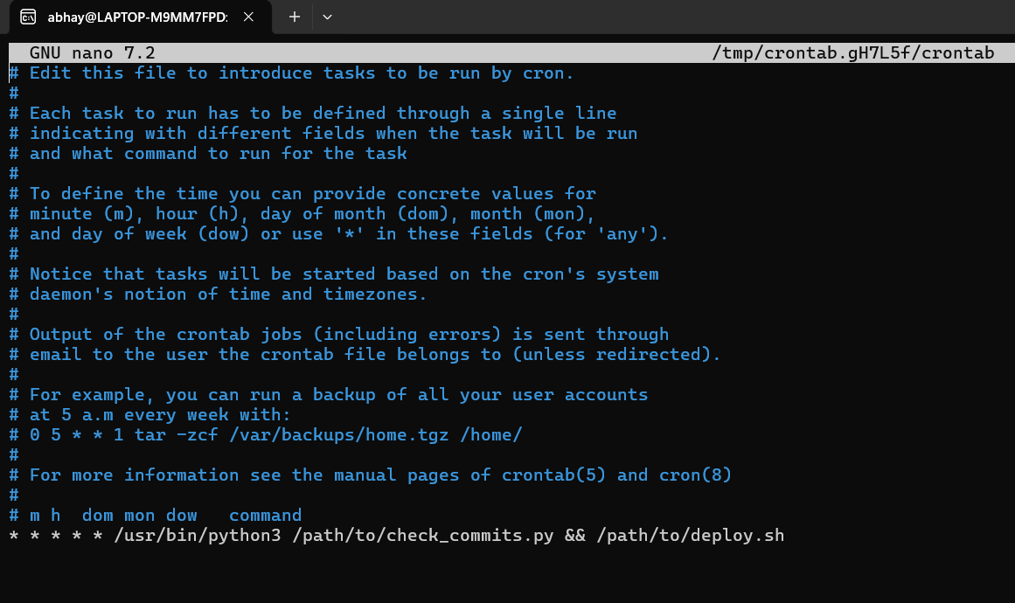

**Task 6: Test the Setup**

1. Make a New Commit:

“echo "<p>Updated content!</p>" >> index.html”

Add and commit the change”

“git add index.html”

“git commit -m "Updated content"”

“git push origin main”

1. Verify Deployment:

• Wait for a minute, then visit server's public IP in a browser.

• See the updated content on webpage.